Before migration, I have developed different steps:
- Compile the net status with NetPro
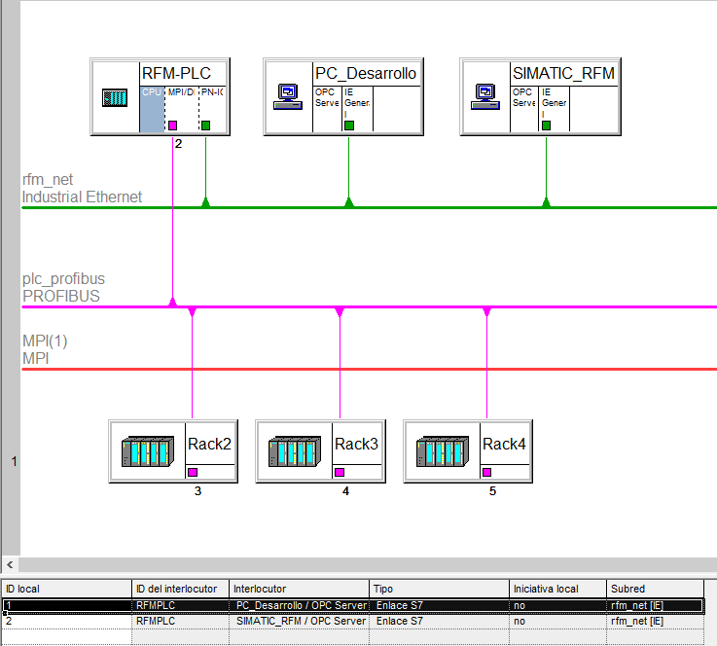
The IP address data: Schematic Net Pro step 7 Classic are:
- PLC: 192.168.1.10 / 24
- PC_Desarrollo: 192.168.1.4 (OPC server)
- Simatic_RFM: 192.168.1. (OPC server)
- Compile the hardware configuration
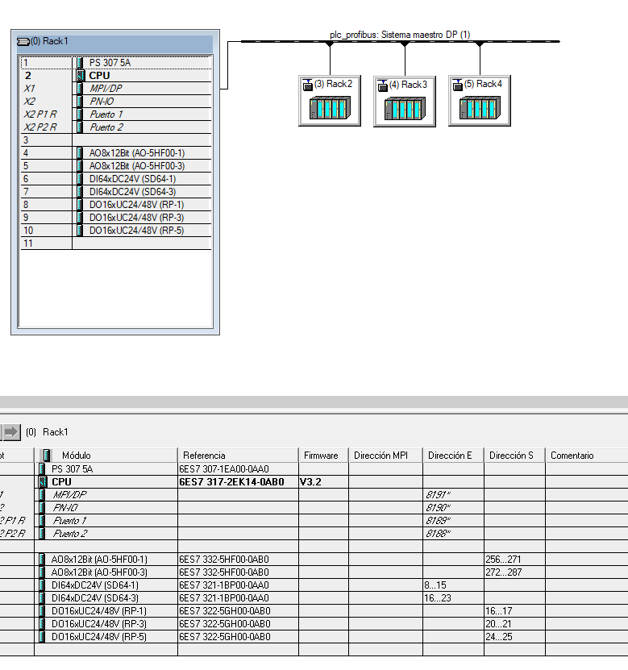

- Check consistent block and compile all blocks.
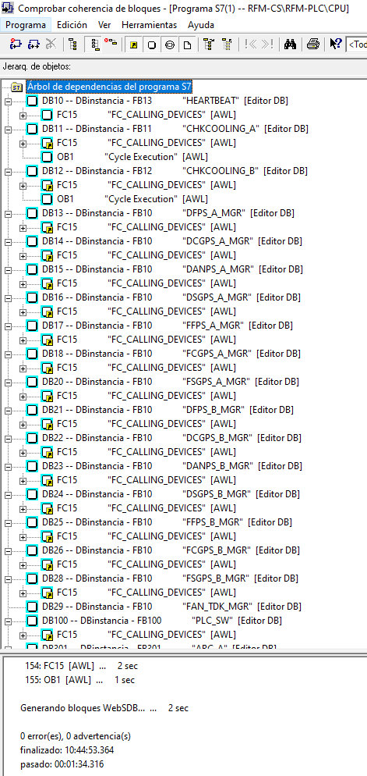

- Start the migration with TIA PORTAL V19.
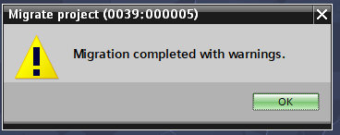
There isn’t an error but there are some warnings (FB8).
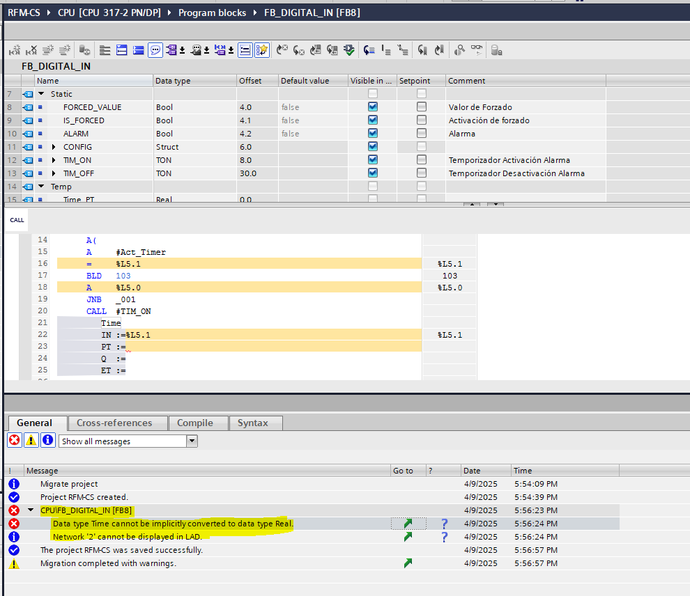
The Fb8 network 2 migration program is:
A "M_TRUE"
= %L5.0
A %L5.0
A #CONFIG.ALARM_ENABLED
A(
A #VALUE
A #CONFIG.ALARM_VALUE
O
AN #VALUE
AN #CONFIG.ALARM_VALUE
)
= #Act_Timer
A(
A(
A #Act_Timer
= %L5.1
BLD 103
A %L5.0
JNB _001
CALL #TIM_ON
time_type:=Time
IN :=%L5.1
PT :=
Q :=
ET :=

_001: A BR
)
JNB _002
L #TIM_ON.PT
T #Time_PT
SET
SAVE
CLR
_002: A BR
)
A(
O #TIM_ON.Q
O
A #Act_Timer
A(
L #Time_PT
L 0.0
==R
)
)
S #ALARM
There are warnings in the network 2 of FB8, and I solved with this code:
